WordPress Theme Report

Themes are an added option in WordPress to take your website presentation to the next level. They offer customization on visual and logical aspects of your content. You have the option to download a pre-made theme, customize an existing theme, or create your own. This article will delve more into the anatomy, templates, and different types of themes.

**TYPES OF THEMES**

WordPress offers two different types of themes, project themes and child themes. Project themes are often modifications of an existing theme that are used to meet the needs and design goals of a single project. These usually have minimal styling allowing for full flexibility to edit the PHP and template files.

The child theme inherits from a parent theme. Essentially this means that you get all of the functionality and styling of the parent theme and then adjust to fit your specific needs.

**STRUCTURE**

**TEMPLATES**

Within the file structure of a WordPress theme, you will have templates, which are reusable files that can be use to create dynamic pages on your site. You can also customize your pages with partials such as header.php, footer.php, and sidebar.php. Using templates eliminates repeating code in multiple places. To include these files in your page, WordPress has helper functions such as get_header(), get_sidebar(), and get_template_part() for you to use in your index.php file.

WordPress themes begin with a style.css and an index.php file. The style.css file is the main stylesheet for your theme and also contains information at the top that tells WordPress what your theme name is, who the author is, and what the URL of the site is. It also includes tags to help locate it in theme searches. Here is an example of what that looks like:

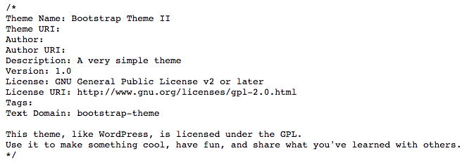

The index.php file controls your homepage theme. Usually this file contains your standard loop. The loop is the heart of WordPress and will be discussed in more detail later in this post. In this index.php file, you will call other templates such as header.php, footer.php, and sidebar.php to put together your site. Think of this as your blank canvas.

The single.php file controls the functions of a single post. This file contains a loop that queries just one post and displays it. It also can include navigational elements, a comments template, and usually the header, footer, and sidebar that is included in your index.php file to keep your pages uniform.

The page.php file controls what your WordPress pages look like. You can choose to eliminate or add elements different from the index.php file. WordPress also allows you to create different page templates for different types of pages. Again, a loop is used on this file to gather the content.

One other key file in the theme anatomy is the functions.php file. This file allows you to modify core elements of your theme by adding your own custom PHP code. Some of the things you can do with functions are enable post thumbnails, post formats, and navigation menus.

**THE LOOP**

The loop is the most powerful part of your WordPress theme. This is placed in your index.php file and determines what to templates or partials to grab to display on your page. Here is an example of a simple loop:

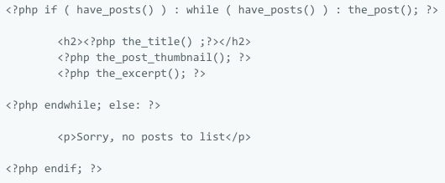Within the loop, you can specify exactly what it should look for like posts titles, content, header, footer, etc. You have the capability of setting up multiple loops within a single page as well. For example, on a single.php page you can have a loop showing the entire content of that post with another loop showing the title and thumbnails of related posts below that.

**CONCLUSION**

WordPress themes take your control beyond just the visual aspects of your site. The presentation and functionality are yours to modify. While creating your own theme might be a bit more advanced than your skill level, give it a shot and see what you can come up with or play around with an existing theme to discover just how powerful these tools are.

**************COMMENTS**************

Themes are definitely a huge help in designing the look and function of your site. With the expansive library of different free and paid options that are available, it’s easy to find one that is just right or very close to what you need. It’s easy to see how a programmer with the skill of theme creation would be in high demand.

Link to live post:

<http://hraemoore.com/wordpress-themes/>